Opening words …. From Isaiah 60:1-3

Prayers of Adoration, Confession and Lord’s Prayer

Loving God,
We praise you for the rich tapestry of life.
The deep colours of creation which enrich our senses
The iridescent blues of the oceans
The multi-coloured skies
The lush countryside and gardens
The glimmering hills and refreshing breeze

The fabric and texture of our community

All this you have given to us... because you love us.

We praise you for the diversity of humanity

The abundance of people who touch our hearts, especially at this time of self-isolation

A baby’s first smile

A child’s enthusiastic story

A sweetheart’s loving glance

A friend’s tender look

An unexpected generous act of kindness
All this you have given us ...because you love us

We thank you for the richness and variety in our lives
For it is here we see you in all your glory
In humanity and creation.

However, we are also mindful of the things that have wounded others this week, by thought, word or deed, and in the silence we come seeking your forgiveness.
Silence…..
Lord, by your grace we are healed, restored and forgiven.
You say to each of us ‘your sins are truly forgiven’; but you also say ‘Come and follow me’.

The Lord’s prayer

Reading John 1:1-5

Reflection

This week we have all been advised by the Government to self-isolate, and to be no less than 2 metres away from anyone. This is not a new phenomenon. In the English Middle Ages, Julian of Norwich decided to self-isolate, in other words be in permanent seclusion in a church in Norwich. Through her three small windows she witnessed the devasting effects that the Black Death had on her community, and on the people she loved. The windows were her opportunity to reflect on where God was in her environment, to pray and to be there for people, to be light in their darkness; and in turn they cared and fed her.
Being an anchorite meant that she was available 24 hours a day to pray for God’s people and to communicate with people who had problems and concerns; and the community knew that she was a light shining from the church cell in the midst of their darkness.
She wrote many reflections about God’s presence and wrote the earliest surviving book in the English language to be written by a woman, ‘Revelations of Divine Love’; but the most important fact for Julian was that God was loving and faithful. The world could learn such a lot from Julian today. And so, we return to the opening words of this reflection, ‘I am the light of the world, and the darkness shall never overcome it.’ More than ever in this time of uncertainty and living in the shadowlands of life, we need to hold close to us the light of Christ, a light that shines in the midst of uncertainty, a light that shines in the midst of chaos, a light that shines in the midst of death.
And Paul writes in Romans 8:22, ‘the whole of creation has been groaning in labour pains, not only creation, but ourselves.’
Something had to happen to make humanity stop and reflect on what is happening to our world, its people and society - and yes, we will be changed by it.
This will be a marathon, but as God’s people we hear God saying 'come to me all who are heavy laden, and I will give you rest'.
My final words come from Julian of Norwich
All shall be well, and all shall be well
and all manner of thing shall be well.
Prayers of Intercession
God who radiates light, and eliminates the darkness from our lives,
we pray that, by your Holy Spirit, you would bring strength, courage, peace and hope to all people who are living in darkness or in the shadowlands of life.

We pray for the families who have been affected by the coronavirus
We pray for wisdom among our politicians
We pray for NHS staff
We pray for volunteers
We pray for children and young people

In the silence we bring before you people we know and love who are needing your strength, and situations that are needing wisdom and clarity.
Silence………
Jesus who is the Christ, help us to seek your light in others, and may others seek your light within us.
Amen

Keep safe my friends, and it has good to share worship with you this morning.

Closing prayer
(Let us say the closing prayer together)

God, of thy goodness, give me Thyself;
for Thou art enough for me,
and I can ask for nothing less
that can be full honour to Thee.
And if I ask anything that is less,
ever shall I be in want,
for only in Thee have I all.
Julian of Norwich

Blessing

Fleet and Beacon Hill

United Reformed Church
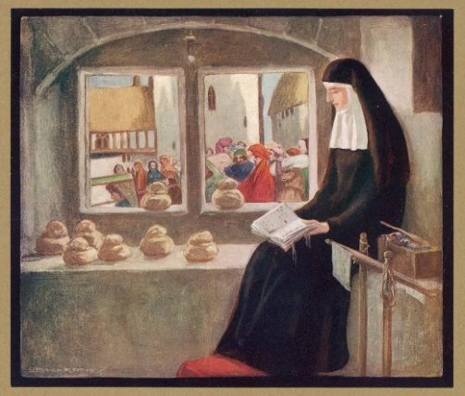

Video Worship 10.00 am
Sunday 29th March 2020
Conducted by Revd Ruth Dillon

This week, I have been aware of social distancing and social isolation: the Government’s strategy to address and stem the acceleration of Coronavirus within the United Kingdom.

Being in social isolation goes against our natural human instincts.
As human beings we are social people, thriving on interaction and touch yet, as God’s people, we called to be people who shine with the Holy Spirit within us, whether that is in social isolation or through social distancing.

So my words and reflection today are helped by a 14th century English Anchoress, Christian Theologian and writer, Julian of Norwich, including encouraging words from Scripture, about the difference of darkness and light in our lives.

But let us start our worship this morning with words from The Bible.

