Worship for Fleet URC & Beacon Hill URC
Sunday 14th March 2021
Seeds of Hope: The Light of God
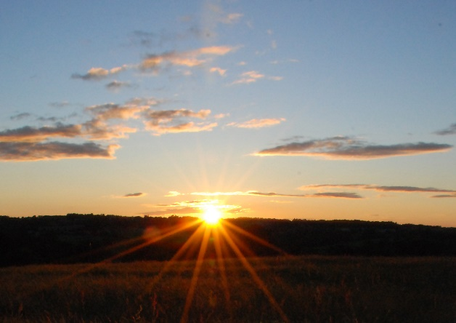
Led by Thelma Roberts
Opening music: We praise God in the morning
Welcome & Gathering Prayer Hugh Le Fanu
In this season of Lent we reflect on our journey of faith with Christ, remembering all the ways God throughout history has delivered the people, through the Red Sea, crossing the river Jordan, and through the waters of our rebirth at our baptism. We know Christ is the spring of living water, and through Christ we will never thirst again for eternal life.
We light this candle on this fourth Sunday of Lent, remembering God’s love for us through his son Jesus the Christ, that we might have new life in him.
Prayer: As the days lengthen and the rivers fill with spring waters, dear God, may we be filled with your love. Let wellsprings of living water spring up in us. In the name of Christ, with whom we journey towards the cross, we pray. Amen.

Call to worship

Heavenly Father, we gather in your name and we worship you here today.
Grant to each one of us the peace and the security,
the comfort and the courage that your presence brings.

Prayers of Adoration & Confession

Lord God, we approach your light.
The light that shines in the darkness of our world.
The light that searches the darkness of our hearts.
The light that banishes the shadows that surround us.
The light that causes some to turn away because they prefer the darkness.
But we lift our faces to your light and walk towards you. Lord God, we approach your light. Amen.

Heavenly Father, we worship you as the life force of the universe,
flowing through all things, sustaining and reviving.
We worship you in the light that falls on us unseen,
blessing us and guiding us towards you.
We worship you for the love that nurtures us.
Life, light and love, we adore you. Amen

Lord, your light has flooded the world;
but we have turned away, preferring darkness.
Lord, you have lifted up your Son that we might be forgiven;
but we have turned away, preferring to remain in our sins.
Lord, you have offered us eternal life;
but we have turned away, preferring the pleasures of earthly life.
Forgive us, O Lord, as we bow our heads before you.
We do not turn away any longer.
We lift our faces to seek your light.
We lift our eyes to see your Son.
We lift our hearts to live in you, and for you, for ever. Amen

Lord’s Prayer led by Robert Mitchell
Our Father, who art in heaven,
hallowed be thy name.
Thy Kingdom come, thy will be done,
on earth as it is in heaven
Give us this day our daily bread.
And forgive us our trespasses,
as we forgive those who trespass against us.
And lead us not into temptation,
but deliver us from evil.
For thine is the kingdom, the power and the glory, for ever and ever. Amen

Hymn: Breathe on us, Breath of God
Breathe on us, Breath of God
fill us with life anew,
that we may love what thou dost love,
and do what thou wouldst do.
Breathe on us, Breath of God,
until our hearts are pure;
until with thee we will one will,
to do and to endure.
Breathe on us, Breath of God,
till we are wholly thine;
until this earthly part of us
glows with thy fire divine.
Breathe on us, Breath of God:
so shall we never die,
but live with thee the perfect life
of thine eternity.

Reading: John 3: 14 – 21 read by Moira Bamfield
¹⁴And just as Moses lifted up the serpent in the wilderness, so must the Son of Man be lifted up, ¹⁵that whoever believes in him may have eternal life. ¹⁶“For God so loved the world that he gave his only Son, so that everyone who believes in him may not perish but may have eternal life. ¹⁷“Indeed, God did not send the Son into the world to condemn the world, but in order that the world might be saved through him. ¹⁸Those who believe in him are not condemned; but those who do not believe are condemned already, because they have not believed in the name of the only Son of God. ¹⁹And this is the judgment, that the light has come into the world, and people loved darkness rather than light because their deeds were evil. ²⁰For all who do evil hate the light and do not come to the light, so that their deeds may not be exposed. ²¹But those who do what is true come to the light, so that it may be clearly seen that their deeds have been done in God.”
This is the Word of the Lord
Thanks be to God

Reflection:
Three young trees in the forest were discussing their ambitions. The first tree wants to be a treasure chest, the second tree a mighty ship, the third tree wants to be so tall it points to heaven. But things didn't turn out like that. The first tree becomes a manger, the second a fishing boat, the third a cross. Each played a part in the story of Jesus.

Our lives have been turned upside down. We planned holidays, family celebrations fun events, but the pandemic put a stop to that. Instead we were all forced indoors not something that we had expected. But, the lockdowns have changed us. The pandemic has made the nation kinder. Rainbows in windows clapping for the NHS, shopping for neighbours, friendly phone calls. We have shown compassion caring for each other and realising that kindness is infectious. Let's not lose our love as we slowly emerge from lockdown

It has been suggested that the 11th commandment should be...Be not indifferent . Do not be a bystander.. . Jesus was there for the poor, the sick, sad and scared. He showed us how to love, how to care. He saw the destructive nature of mankind. He saw the imbalance. A selfish world devoid of Love. He taught us that love, true love, was at our very core, and we have to go on loving and caring as He taught us.

In the reading today it says....God so loved the world that He gave HIs only begotten son that whoever believes in Him shall not perish but have eternal life. God loved the world. He loved the whole world, not a part of it, the whole world.

If you watched the inauguration of President Joe Biden, you would have heard a poem read by Amanda Gorman. Toward a the end of the poem, she said....’There is always light, if only we are brave enough to see it.’ If only we are brave enough to be it. We have had very dark times, many tears, times when perhaps our faith wobbled. In a world of darkness it takes a lot of courage to see the light, but it's always there. Jesus is the light, and His light shines in the darkness guiding us and showing us the way.

I hear you have been planting seeds of hope and love for Lent, such a great idea. You all know that plants need to be looked after, nurtured for them to be healthy and strong and it’s the same for us. We need all the help we can get. We need to be loved and cared for so that we can grow and flourish.

Amen.

Prayer...Lord, we thank you for this season of Lent.
This time which invites us to pause and take stock, and reflect on the things which really matter

Hymn: Help us accept each other
Fred Kaan Words © 1975 Hope Publishing Company
Sung by Ray Stanyon

Help us accept each other
As Christ accepted us;
Teach us as sister, brother,
Each person to embrace.
Be present, Lord, among us
And bring us to believe
We are ourselves accepted
And meant to love and live.
Teach us, O Lord, Your lessons,
As in our daily life
We struggle to be human
And search for hope and faith.
Teach us to care for people,
For all, not just for some,
To love them as we find them
Or as they may become.
Let Your acceptance change us,
So that we may be moved
In living situations
To do the truth in love;
To practice Your acceptance
Until we know by heart
The table of forgiveness
And laughter's healing art.
Lord, for today's encounters
With all who are in need,
Who hunger for acceptance,
For justice and for bread,
We need new eyes for seeing,
New hands for holding on:
Renew us with Your Spirit;
Lord, free us, make us one!

Prayers of Intercession led by Thelma

Blessing

Lord of light, help us to look to you in the coming week.
Guide us when the way ahead seems dark and full of obstacles.
May we always give thanks, even in the darkest times,
And enable us to shine as lights in the world. Amen

Closing music: Light of the World forever, ever, shining

Responses led by Robert Mitchell
Opening music from STF 140 - We Praise God In The Morning (Swung Rhythm) part of Singing The Faith; Contributed by Paul Wood & Ian Worsfold | The Worship Cloud
Closing music: https://www.smallchurchmusic.com/Snippet/S-LightOfTheWorld-Berwyn-PipeLC-48-CAM.mp3
Hymns: Breathe on us breath of God | Evangelical Movement of Wales (emw.org.uk)
Help us accept each other sung by Ray Stanyon by permission
Hymns reproduced & streamed under CCLI 6025 & CCLI 21997 respectively
Prayers: ROOTS | Worship and learning for the whole Church (rootsontheweb.com)

