Worship for Fleet URC & Beacon Hill URC

Friday April 2nd 2021 at 3 p.m.
Good Friday

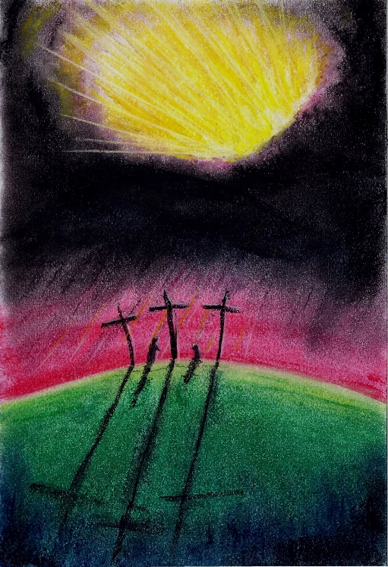

Led by Karen Smith

Opening music Were you there when they crucified my Lord?

Welcome We come together on this Good Friday for a time of reflection and prayer.

Prayer
Loving God, we come before you, in worship, praise, thanksgiving and remembrance. Today of all days we are reminded just how much we owe you, how great a price you are willing to pay to give us the gift of life.
Open our hearts to the presence of Christ and lead us in his way

We come, recalling the last hours in the life of Jesus and all it teaches us of Him –
His faithfulness to the last, his willingness to take the Way of the cross, his courage in the face of opposition, suffering and death.
Open our hearts to the presence of Christ and lead us in his way

We come thankful for all He has done and continues to do, celebrating his great love.
Open our hearts to the presence of Christ and lead us in his way

Receive now this time of worship we offer to you,
And speak through it so that we may grow in faith and be strengthened in your service.
Open our hearts to the presence of Christ and lead us in his way
for in His name we ask it. Amen

It is Friday -- An invocation and poem for Good Friday
It is Friday
And I stand at the foot of the cross.
Nothing can be said, nothing can be done.
Action is futile
I can hold the other's hands and weep, but I cannot be comforted.
It is Friday
And I stand at the foot of the cross.
The air is heavy still with waiting and longing.
Waiting for the inevitable, longing for the impossible.
Can this cup pass from me?
I look around me – all the colours are muted.
Dusty browns and greys – Cold and metallic.
Rolling black clouds cover the brilliant blue of the sky
As my soul is occluded by pain.
All that remains is the red of the blood
Running down the weathered wood of the cross.
It is Friday
And I stand at the foot of the cross.
I reach out and touch the raised grain of the wood.
It is rough against my fingertips.
The smell of unwashed wool and bodies crowds my nose.
I smell fear, pain, death. I taste it at the back of my throat.
I hear the laboured breathing from the cross.
Death is near.
It is Friday
And I stand at the foot of the cross.
Remember Him!
Remember Him as the silver cord is severed, as the golden bowl is broken.
Remember Him as the pitcher is shattered at the spring and the wheel broken at the well.
Remember Him as the dust returns to the ground it came from and His spirit returns to the God who gave it.
It is Friday
And I stand at the foot of the cross.

Hymn: When I survey the wondrous cross
Sung by the Newcastle Virtual Choir

When I survey the wondrous cross
On which the Prince of Glory died
My richest gain I count but loss
And pour contempt on all my pride.

Forbid it Lord that I should boast
Save in the death of Christ my God
All the vain things that charm me most
I sacrifice them to His blood.

See from His head His hands His feet
Sorrow and love flow mingled down
Did e'er such love and sorrow meet
Or thorns compose so rich a crown.

Were the whole realm of nature mine
That were an offering far too small
Love so amazing so divine
Demands my soul my life my all.

Bible reading John 19: 25 -30 read by Robert Mitchell

25 Near the cross of Jesus stood his mother, his mother’s sister, Mary the wife of Clopas, and Mary Magdalene. 26 When Jesus saw his mother there, and the disciple whom he loved standing nearby, he said to her, “Woman,here is your son,” 27 and to the disciple, “Here is your mother.” From that time on, this disciple took her into his home.
28 Later, knowing that everything had now been finished, and so that Scripture would be fulfilled, Jesus said, “I am thirsty.”
29 A jar of wine vinegar was there, so they soaked a sponge in it, put the sponge on a stalk of the hyssop plant, and lifted it to Jesus’ lips. 30 When he had received the drink, Jesus said, “It is finished.” With that, he bowed his head and gave up his spirit.

A psalm of desolation read by Margaret Armes

Where prisoners are denied justice,
Humiliated and shamed by abuse,
Their torture ignored and their voices silenced,
You, crucified God, are there, bearing the sin of the world.

Amongst the people we find repulsive,
Disfigured with infectious disease,
And scarred by marks of violence,
You, crucified God, are there, bearing the sin of the world.

In communities and towns under siege,
Where people are beaten and insulted,
Where abuse and neglect are unchecked,
You, crucified God, are there, bearing the sin of the world.

Loving God, who has carried us like a father,
Cradled us like a mother,
Do not abandon your people now.
Bring healing and justice and the praise of your name
To the places that feel forsaken in your beloved world.
© Jan Berry URC Prayer Handbook 2011 still praying

Guided silence
They looked upon the One they had pierced
And we too look on the one who died, and wonder…
We wonder why – why this final insult on one already dead.
(Pause…)

They looked upon the One they had pierced and saw blood flowing from His hands – His feet – His side
And we too look upon the one who died, and wonder….
We wonder that such an offering had to be made –
The blood of a spotless lamb. Was God so angry with his people?
(Pause…)
They looked upon the One they had pierced and saw water flowing from the wound in His side
And we too look upon the one who died, and wonder….
We wonder at the greatness of this gift:
Water from his side – that washes our sin away-
Water from one who died offering us a way to new life
(Pause…)
They looked upon the One they had pierced
and thought that they had won –
the Word of God was silenced –
the Light of the World was extinguished –
the Way was blocked –
the Truth questioned –
the Life was dead.
Father, forgive them – they did not know what they were doing.
Father, forgive us- for often we do not know what we are doing.
(Pause….)

They looked upon the One they had pierced and thought that they had judged rightly –
the Son of God who challenged their gods was wrong
and they had defeated Him.
But God did not send his son into the world to judge it,
to condemn it.
God sent his Son, the beloved, into the world to save it –
to save us (Pause….)
They looked upon the One they had pierced and saw death and emptiness
And we too look upon the one who died, and wonder…..
We wonder at so great a love –
a love that does not count the cost of loving –
a love that offers its very self so that we might live –
a love that would have done the same
had I been the only one that needed it.
(Pause)
The sacrifice of love stretched out His arms on the cross
and sent forth His Spirit into the outstretched arms of the Father
So great a love so great a sacrifice…

Concluding music: Were you there when they crucified my Lord?
Sung and produced by Ray Stanyon, with thanks

Responses led by Anna Smith
Opening music: STF 285 - Were You There? part of Singing The Faith; Contributed by Paul Wood & Ian Worsfold | The Worship Cloud
Closing music: Sung & produced by Rev’d Ray Stanyon by permission
Hymn: Virtual Church Choir - Newcastle Cathedral by permission
Hymn reproduced & streamed under CCLI 6025 & CCLI 21997 respectively

