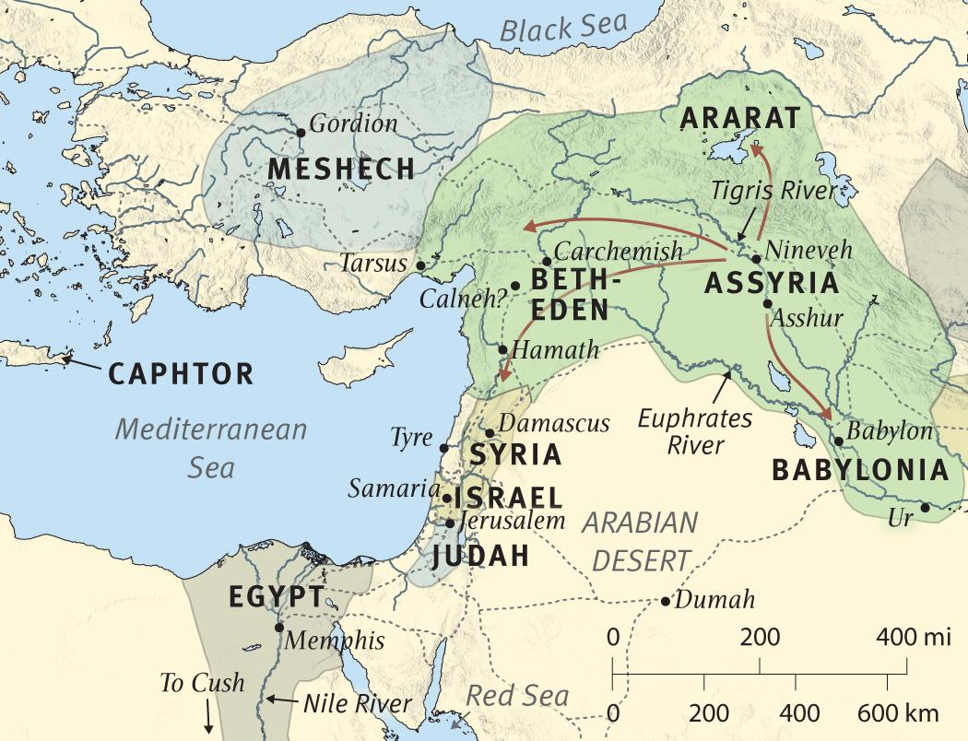

Standing in the sandals of the prophets
Bible Study Group 2021 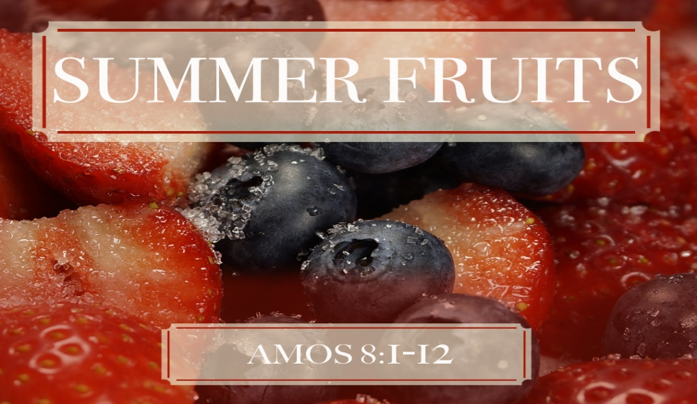
July 19th 2021
Fleet URC & Beacon Hill URC

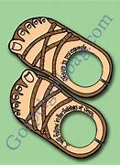
Amos: who?
If you can, read the book of Amos before the session. We will select some verses to focus on as well, so don’t be concerned if you have yet to read it. Hopefully, our talking about it will make it attractive to do so! Here is some background as a starting point:
Amos was not always a prophet but nevertheless was entrusted with bringing a message from the Lord to the northern kingdom of Israel. He prophesied sometime between 793–739 B.C., probably nearer the end of that period. So in the context of our Old Testament studies so far, Amos is prophesying c.200 years before the setting of Nehemiah.
Timeline:
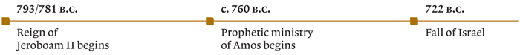
After about 780–745 B.C., the Assyrian Empire was unable to continue the pressure it had put on the nations of the Canaanite coast during the previous century. At this same time, both Judah and Israel were blessed with fairly stable governments. As a result of these two factors, the two nations (especially Israel) were experiencing a time of wealth and prosperity. But what the Israelites saw as the beginning of a new “Golden Age” was really the end for them. It was Amos’s unhappy task to tell them of God’s coming judgment. Within just a few years Israel would no longer exist as a nation. They would continue to exist as a scattered people only by God’s unmerited grace (9:11–15). “The day of the Lord,” far from being a day of blessing, was going to be a day of darkness. By 722 B.C. Assyria would regain its strength, and the Israelites would be conquered and exiled.
To open: a prayer led by Karen
Let’s get a feel for the geography………………….
- Look at the map on the back page of this leaflet
- Any thoughts or questions?
Who is the man in the sandals named Amos?
Scripture text: Amos 1:1; Amos 7: 14 - 15
Discussion points:
What do we learn about Amos from these verses? We can think about:
- What do we know about his heritage?
- Where is he living before he starts prophesying?
- What does he do (his work)?
What is the book of Amos about?
Scripture text: Amos 2: 6 – 8; 3: 10; 4:1, 4 & 5; 5: 10 – 13; 6: 12; 8: 4 -6
- What are the main messages you can identify in Amos?
- How would you describe his words in comparison to other books of prophets you may have read?
- How would you describe the approach to worship Amos condemns? What parallels do you see with Jesus’s ministry?
- How does the book of Amos touch us in 2021?

