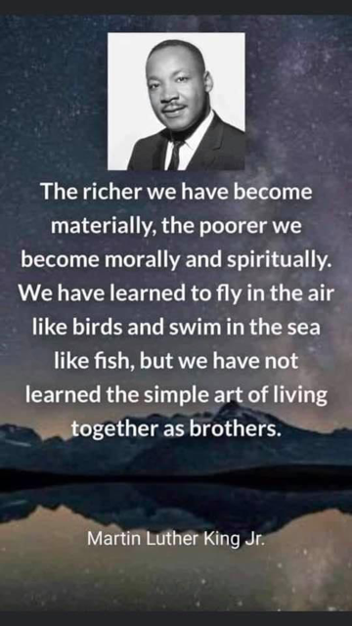

Standing in the sandals of the prophets
Bible Study Group 2021 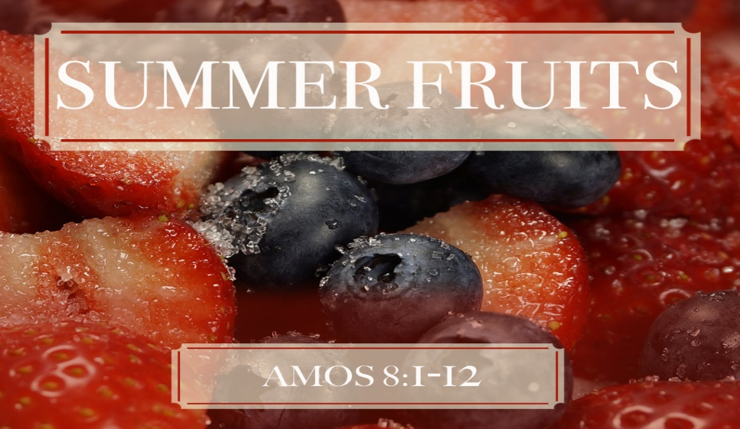
20th September 2021
Fleet URC & Beacon Hill URC

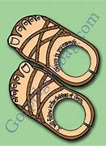
Amos:
If you can, read the book of Amos before the session. We will select some verses to focus on as well, so don’t be concerned if you have yet to read it. Hopefully, our talking about it will make it attractive to do so!
Here is a summary of some of the points made at the July discussion:
We established that we were reading a prophetic text. During the long and peaceful reign of Jeroboam II (786-746 BC) Israel attained a height of territorial expansion and national prosperity. The military security and economical & political affluence which characterized this age were taken by many Israelites as signs of the Lord’s special favour. Amos was called by God to the difficult mission of preaching harsh words in a prosperous season. He denounced Israel, as well as her neighbours, for reliance upon military might, and for grave injustice in social dealings, abhorrent immorality, and shallow, meaningless piety in the first chapter, cleverly talking of the other clans before finally denouncing Israel.
Amos was a shepherd in a region called Tekoa, about six miles south of Bethlehem. We identifed two jobs Amos performed: he kept sheep (Amos 1:1), and he cultivated sycamore trees (Amos 7:14).

To open: a prayer led by Karen
Scripture text: Amos 3: 3 - 6
Discussion points:
- What is your answer to these questions?
- What is God’s point?
- Why does God ask these questions?
Scripture text: Amos 2:6, 2:8, 3:9-15, 4:1, 5:7, 5:11 & 12, 5:21-23, 8:4 – 6.
- What were the sins of the nation?
- If you were asked to summarise the teaching of Amos, what would you say?
The final message in the Book of Amos
- Is there only doom and gloom for Israel?
- Ch.9 completes the Book of Amos: what is the tone of the Book as it closes? How does that make you feel?

