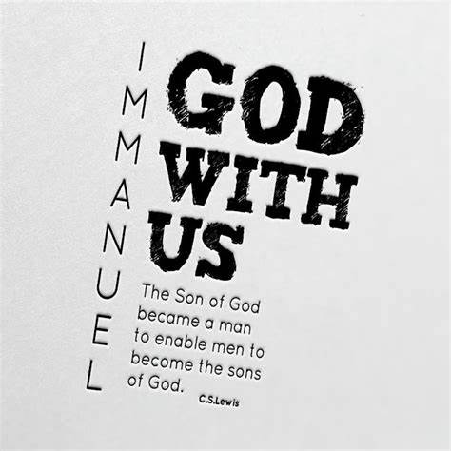

Standing in the sandals of the prophets
Bible Study Group 2021

18th October 2021
Fleet URC & Beacon Hill URC


Isaiah:
If you can, read Isaiah chapters 6 – 9 before the session. We will select some verses to focus on as well, so don’t be concerned if you have yet to read it. Hopefully, our talking about it will make sense of it.
Here are some thoughts on the Book of Isaiah:
One tricky element is the way in which Isaiah jumps around from time period to time period. Most scholars would place the first part of Isaiah in the eighth century BC, the second section in the sixth century BC and the third section in the late sixth or early fifth century BC. As a result it can be a bit difficult to know where you are.
Isaiah prophesied on more than one occasion about someone who was coming to save God’s people. Christians believe this person to be Jesus; Jews do not.
Isaiah son of Amoz (not the Amos from the Minor Prophets but someone else) was a prophet in the eighth century BC. The traditional view is that Isaiah wrote the whole book and that 40–55 and 56–66 were prophecies by Isaiah of what would happen in the far future. Many modern scholars, however, think the book began with Isaiah’s prophecies but was added to over time. Indeed 8.16 (‘Bind up the testimony, seal the teaching among my disciples’) implies that Isaiah’s original prophecies are to be kept by his disciples until a future moment. This suggests that Isaiah’s disciples preserved the prophecies and then opened them again as the exile came to an end and added to them, and again when they actually returned from exile.

What do we know about him?
Isaiah 1.1 states that Isaiah was active during the reigns of Kings Uzziah, Jotham, Ahaz and Hezekiah. This probably locates his prophecies between 740 and 698 BC.
To open: as a prayer ‘I the Lord of sea and sky’
Scripture text: Isaiah’s commission
Isaiah 6: 1 - 8
Discussion points:
- What do these verses say to you about Isaiah?
- What is Isaiah’s reaction to the vision? How does God deal with Isaiah’s fear?
- What question follows Isaiah’s cleansing? What is Isaiah’s response to God’s question?
- What is your response when you sense God calling you?
Scripture text: Isaiah’s prophecy
Isaiah 7: 1 - 13
- What was the gist of Isaiah’s prophetic instruction to Ahaz? Why do you think Ahaz chose to disregard it? What did Ahaz do instead?
- What was the consequence of this disobedience? Why do we sometimes seem to think that we’re smarter than God?
- Why is it sometimes so hard to do what God tells us to do?
Scripture text: Children with meaningful names
Isaiah 7: 3; 14 – 17
- How does Isaiah use children’s names as signs & symbols?

