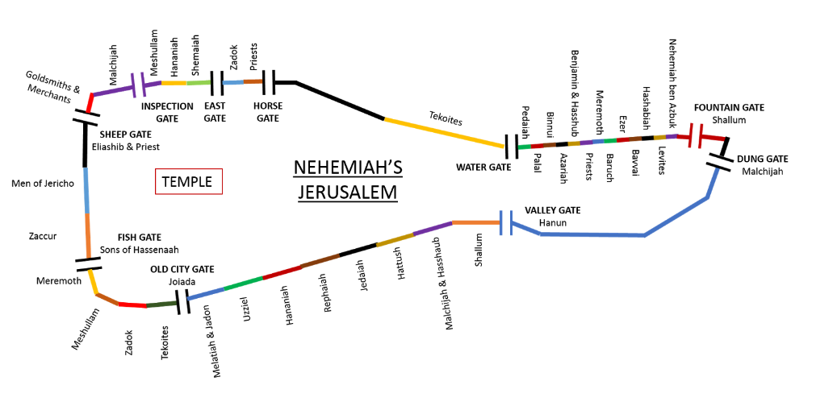

Standing in the sandals of the prophets
Bible Study Group 2021
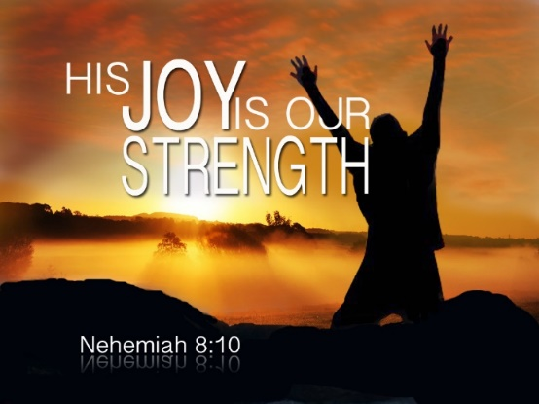
April 19th 2021
Fleet URC & Beacon Hill URC

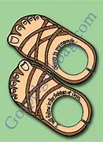

Nehemiah: who?
If you can, read the book of Nehemiah before the session. We will select some verses to focus on as well, so don’t be concerned if you have yet to read it. Hopefully, our talking about it will make it attractive to do so! Here is some background as a starting point:
An introduction to the book of Nehemiah
In 586 BC the Babylonians, under King Nebuchadnezzar, destroyed the city of Jerusalem, and took most of the inhabitants into Exile. We read in 2 Kings 24:14, that King Nebuchadnezzar, “…carried away all Jerusalem, all the officials, all the warriors, ten thousand captives, all the artisans and the smiths; no one remained, except the poorest people of the land”. But God does not abandon His people, nor does God leave them without hope. As the prophet Jeremiah proclaims, “For surely, I know the plans I have for you, says the LORD, plans for your welfare and not for harm, to give you a future with hope. Then when you call upon me and come and pray to me, I will hear you. When you search for me, you will find me; if you seek me with all your heart, I will let you find me, says the LORD, and I will restore your fortunes and gather you from all the nations and all the places where I have driven you, says the LORD, and I will bring you back to the place from which I sent you into exile” (Jeremiah 29:11-14). In 539 BC the Persians and Medes, led by Cyrus the Great, defeated the Babylonians, and ended the Exile. As we read in the Old Testament books of Ezra and Nehemiah, God’s people returned to the Land of Promise in three distinct waves in the 5th and 4th centuries BC. A 1st wave, under the leadership of Zerubbabel, returned to Jerusalem to rebuild the Temple and restore the sacrificial cult (see Ezra 1-6). A 2nd wave, led by the scribe Ezra, returned to Jerusalem to initiate a spiritual and social renewal among God’s people. Ezra sought to rebuild the community by teaching Torah (see Ezra 7-10). Nehemiah’s story is the next step……..
To open: a prayer led by Karen
Who is the man in the sandals named Nehemiah?
Scripture text: Nehemiah 1: 1 - 11
Discussion points:
What do we learn about Nehemiah from these verses? We can think about:
- What do we know about his heritage?
- Where is he living?
- What does he do (his work)?
- What is his reaction to the news he hears & what does this tell us about his character?
Scripture text: Nehemiah 2: 1 – 6
- What do these verses say about his relationship with the king?
Scripture text: Nehemiah 2: 7 – 10; 11 - 17
- What more does this tell us of Nehemiah’s character?
Scripture text: Nehemiah 2: 13
Learning about Jerusalem:
- Have a look at the map to see the referenced gates.
- Are there any familiar gates you recognise from the Gospels?

