A day of returning, a day to remember:
the years of their exile were over and gone,
a day of thanksgiving for such preservation,
a day for rejoicing, a day to move on.

And now they would settle to re-build a kingdom,
to value tradition, to start a new life.
For now they were feasting with joy in communion
with God who walked with them from danger and strife.

And now in this moment we think and remember
the joys and the sorrows we left in the past,
affirming again that our God was among us,
whose love is eternal whose favour will last.

Then let us move forward wherever God leads us,
hold fast to our heritage, cherish God's grace,
take hold of the future, its courage and challenge
will build a new vision for this time and place.
© Andrew Pratt 11/1/2013
Tune: STREETS OF LAREDO
Metre: 12.11.12.11

Standing in the sandals of the prophets
Bible Study Group 2021 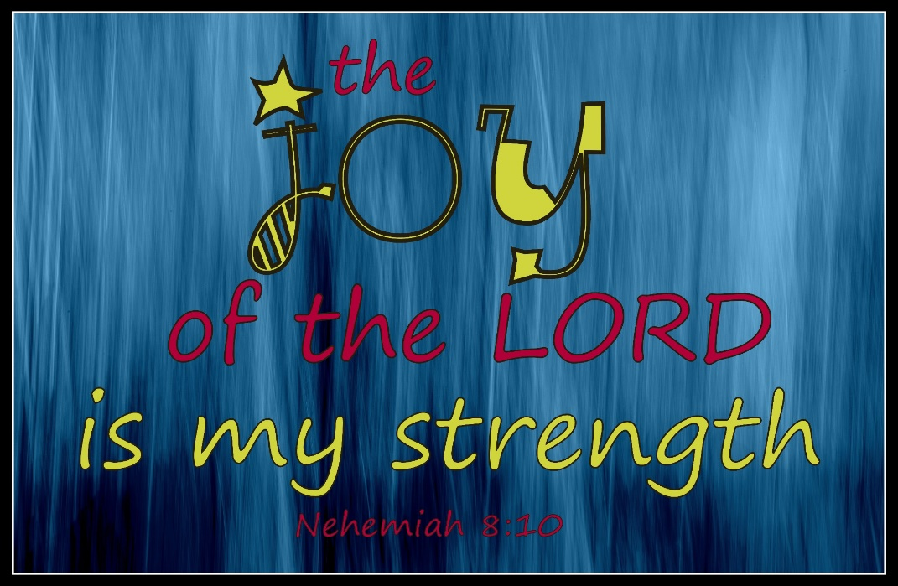
May 17th 2021
Fleet URC & Beacon Hill URC

Nehemiah: what have we learned so far?
If you can, read the book of Nehemiah before the session. We will select some verses to focus on as well, so don’t be concerned if you have yet to read it. Here is a summary of our discussion in April:
Nehemiah was born in exile under the command of the Persians who had defeated the Babylonians. God’s people returned to the Promised Land in three distinct waves in the 5th and 4th centuries BC. Nehemiah’s story is about the third wave.
We built a word picture of the character of Nehemiah from our readings. Even though he was brought up in exile he has a strong religious faith, devoted to following God’s way through prayer and action. The story opens at the Persian king’s winter palace in the city of Susa, which had been mentioned in Daniel. Nehemiah was a senior influential official as cupbearer to the King.
The regard in which he was held was revealed in the support the Persian King gave him to ensure a safe passage to Jerusalem for his visit. He comes over as a shrewd, organised leader.
We also had a short discussion about Jerusalem – so often mentioned in the New Testament - & whether we understood or knew much about it is as a city. The map showed the division of labour to build the wall & we could see the East gate which is thought to be the gate by which Jesus entered the city on Palm Sunday.

To open: a prayer led by Karen
Overcoming opposition
Scripture text: Nehemiah 4: 1 – 23 Galatians 6: 9
Discussion points:
- What types of opposition does Nehemiah experience?
- How does he respond?
- How can we determine the difference between healthy realism that acknowledges problems and unhealthy negativism?
- What can we learn from Nehemiah about leadership; about planning; about responding to opposition?
Nehemiah’s reforms
Scripture text: Nehemiah 9:38; 10: 28 – 39
Matthew 26: 26 – 28
- What are the essential elements of a covenant?
- What did the Israelites commit themselves to so & how might this relate to us?
- Why did the Israelites breakaway from the promises they had made? How could we avoid doing the same?
What are the main things that have resonated with you in reading & studying parts of the book of Nehemiah?

