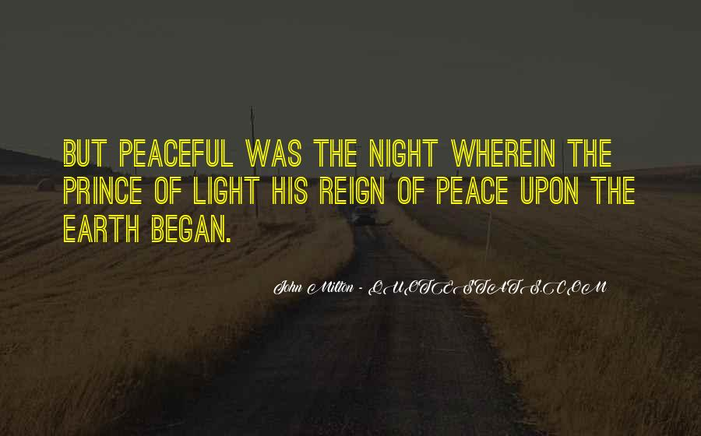

Standing in the sandals of the prophets
Bible Study Group 2021
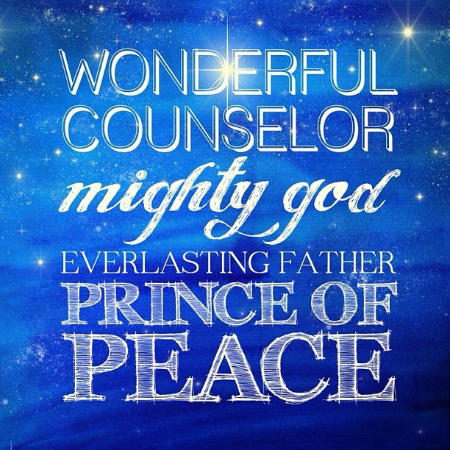
15th November 2021
Fleet URC & Beacon Hill URC

A little of the Book of Isaiah
Here is a brief summary of last month’s discussion on the Book of Isaiah:
Our readings from the prophets have identified the political turmoil, injustice and threats from foreign powers that dominated the OT. Even if we don’t know the names of the kings of Israel & Judah & which prophet was around when, we have a better understanding of their inter connectedness. Often the prophecies are based around the exile from, and return to, the land given to the Hebrew people by Yahweh. We have identified that the inequalities in social justice, the neglect or fragile ability to adhere to God’s laws as part of the covenant and the example of the king as living (or not) within those laws, as recurring themes.
The discussion explored the political context – the hostility, conflict, greed & violence - of early Isaiah, his calling (Here I am, Lord) and something of Immanuel in ch.6.
One conclusion that began to emerge was that the coming of the Messiah in the Old Testament leans heavily on anticipation; that must have been part of the development of faith for early Christians. Today, we are considering how much we have come to interpret the titles pronounced in Isaiah as being represented in Jesus.
We begin: Opening prayer led by Karen
Where we got to last time………
Scripture text: Children with meaningful names
Isaiah 7: 3, 14 -17
• How does Isaiah use children’s names as signs & symbols?

Scripture text: A well-known oracle
Isaiah 9: 2 -7
- If we consider this text in its time, knowing what we now know about the upheaval spoken of by the prophets we have looked at, what is it actually speaking about?
- So why do our Christmas carols speak so often with royal imagery?
- What parallels can you see to the life and ministry of Jesus?
Scripture text: Prince of Peace
Joshua 9:15; Jeremiah 6: 13 -14; Ezekiel 34:25; 37: 26; Isaiah 52:7
- What types of peace can you identify in these verses?
- The ‘peace’ in Isaiah is written as shalom. Looking at the definition below, how is this manifest in Jesus?
Shalom - Hebrew word meaning peace, harmony, wholeness, completeness, prosperity, welfare and tranquillity
- How does the Christian anticipation we know from our Christmas celebrations, based on the oracle in Isaiah, contradict the expectation of ancient Israel?
"Peace I leave with you; my peace I give to you. Not as the world gives do I give to you. Let not your hearts be troubled, neither let them be afraid" (John 14:27).
A prayer to take into Advent:
Gracious God, as we reflect on the Prince of Peace, we remember all the places in the world and in our lives where conflict, hurt & pain reign. Be with all who work for justice and peace and guide us to be better peacemakers. (adapted from a prayer by William Breuggemann)

