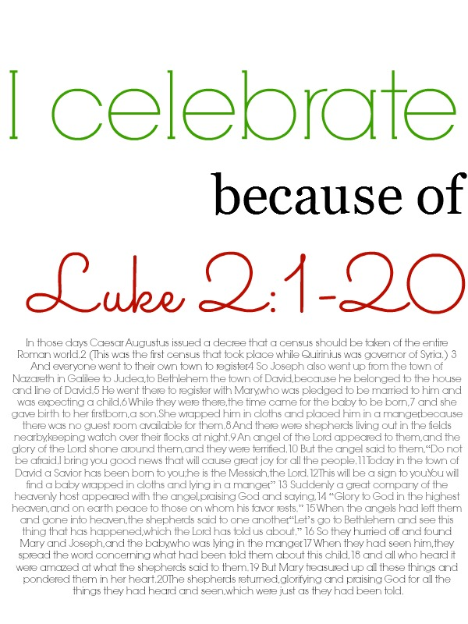

Singing the Songs of Christmas
Nurturing our Faith
Bible Study Group 2021

http://pleasanthillchurch.org/sermons/songs of-christmas-a-song-of-praise/

6th December 2021
Fleet URC & Beacon Hill URC


Singing the Songs of Christmas
Singing is a part of Christmas for all of us! The music in shopping centres, on the radio, on the TV and included in school plays is all pervasive with that special ‘sound of Christmas’. Perhaps that isn’t surprising as songs have been part of the narrative from the very beginning. This time together gives us the opportunity to revisit a couple of those songs – the very first Christmas songs - found in Luke’s Gospel.
Opening prayer led by Karen
We begin:
- There are 5 songs in Luke’s Christmas narrative. Can you identify them?
- William Phillip says: “it is the work of God that leads to song.” What do you think?
Scripture text: He who did not believe……
Luke 1: 67 - 79
- What is the back story to this song?
- What has Zechariah learned?
- What references to the Old Testament can you see in this song?
- What are the images, memories or associations that come to mind when you hear the word ‘salvation’?
Scripture text: The heavenly proclaimers……
Luke 2: 8 – 15
- The angel opens with ‘Fear not’. Why do you think this is the first thing said?
- The angels sing of peace: what does this mean to you – a peaceful earth or peace between humankind and God?
- Who is the message actually about?
- How can we respond to this message today?
Scripture text: A song of great joy
Luke 1: 39 – 43
- What impact does this song have?
Do you recognise any elements of songs from Luke’s Gospel in any Christmas carols?

A prayer for an Advent evening:
Living God, you have rescued us: help us to serve you without fear. You have saved us: help us to go out before you, preparing the way for you in the hearts and minds of your people. You are the dawn that enters the darkness of night: guide our feet in peace until morning. Amen (Amy Scott Robinson)

