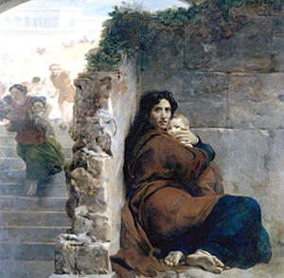
http://omniumsanctorumhiberniae.blogspot.com/2012/12/the-massacre-of-innocents-in-irish.html
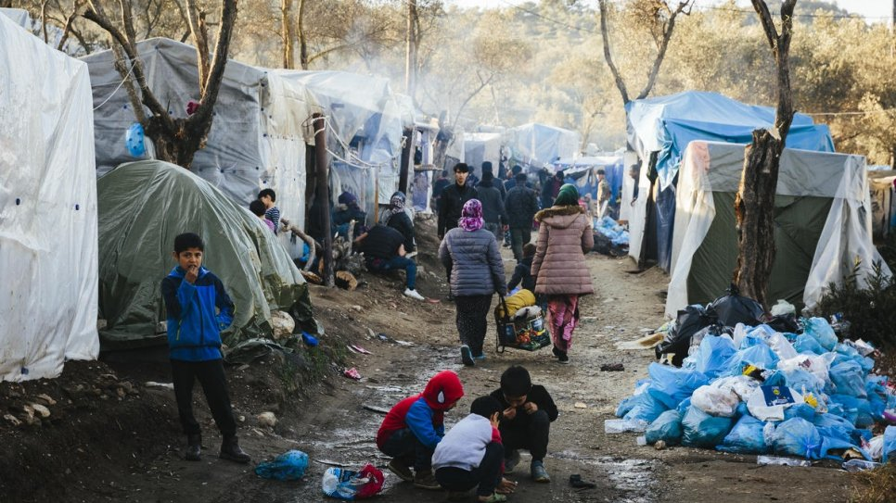

https://www.unhcr.org/news/stories/2020/2/5e4fc07b4/vulnerable-asylum-seekers-struggle-access-medical-care-overcrowded-greek.html

Nurturing our Faith
Bible Study Group 2022


17th January 2022
Fleet URC & Beacon Hill URC
Consequences……….
We all love the Christmas narratives, but what would have been the impact of what happened to all those we read about, central characters and those in the background? Matthew’s Gospel gives us particular events to consider – the arrival of the Magi, King Herod’s response to news of a ‘King of the Jews’ and Mary & Joseph facing another journey with a small boy. This discussion will look at these events and the difficulties that resulted, looking at the faith that must have always been present.

Opening prayer led by Karen
Scripture text: Matthew 2: 7 - 9
- What do these verses tell us about a) The Magi and b) Herod?
12 And having been warned in a dream not to go back to Herod, they returned to their country by another route.
- The Magi were ‘warned in a dream.’ Does that surprise you? If so, in what way? If not, why not?
- What are the consequences of this warning to The Magi?
Scripture text: Matthew 2: 13 - 14
- How do you think Joseph and Mary would have reacted to the dream?
- What prophecy is referred to in v.14?
- What would be the consequences of living in Egypt for the family?
- How might we, as Christians in 2022, respond to those seeking asylum?
Hearing from Herod: a summons to the people of Bethlehem
- Imagine that you are a member of the delegation from Bethlehem. How do you feel?
- How, in our journey with God, can we begin to deal with people like Herod, today?
Scripture text: Matthew 2: 16 -18
- How do you view what happened here?

"Actually, the story is in perfect harmony with what we know of Herod's character in his last years. . . . The death of a few children (perhaps a dozen or so; Bethlehem's total population was not large) would hardly have been recorded in such violent times." (Carson)

- What has Rachel got to do with anything?

