Who is Christ for us today?
- Do these ‘I am’ saying have relevance today?
- How would you explain what it means to believe that Jesus is the Good Shepherd? What he meant was that…
- What do you feel the Church might be in danger of forgetting about Christ?
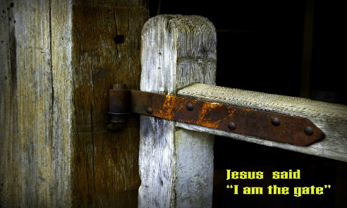 Read Psalm 23 aloud. This is a powerful picture of the Lord as our shepherd. Consider one specific area of your life where you need Jesus to be your shepherd.
PRAYER
Jesus,
You wonderfully call each one of us by name.
We ask that through your Spirit we hear and recognise your voice;
so that you truly become the shepherd, the leader,
the one who guides us through our lives and through the gate
into the fold of your embrace. Amen.

Who is Christ for us today?

Nurturing our Faith
Bible Study Group
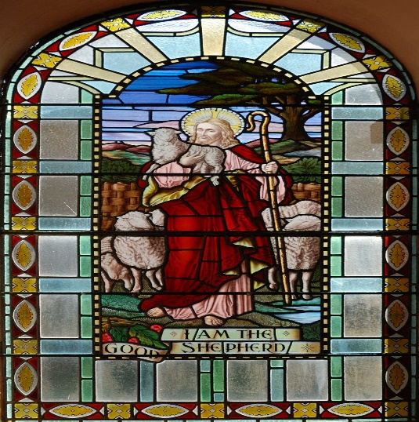
20th June 2022
Fleet URC & Beacon Hill URC
Who is Christ for us today?
The teaching of Jesus was always relevant and meaningful to hi. He used metaphors and analogies that would have struck powerful chords with those who heard them, to help him reinforce a particular point.
The ‘I am’ sayings continued
Last time, we discussed our understanding and thinking about ‘I am the Bread of life’ and the charge that gives us:
Out of your generosity, we find ourselves satisfied.
Out of our abundance, may we feed others.
Opening prayer sung by Kristyn Getty: Good Shepherd of my Soul
I am the gate for the sheep  I am the good shepherd | John 10: 1 - 20

- This week we are looking at Jesus’ parallel statements “I am the gate” (John 10:7) and “I am the good shepherd” (10:11). In Jesus’ day, animals were often kept in a courtyard that was enclosed by a wall and was attached to a building. The sheep were led into the courtyard through a gate which kept them secure and safe. What sort of contrast does Jesus make between himself as the gate and the thieves & robbers in verses 7-10?
- How does Jesus’ striking statement in verse 10 shed light on His purpose as the gate?
- Jesus changes the picture a bit as He goes on to describe Himself as “the good shepherd” (10:11, 14). The Hebrew Bible – our Old Testament – is rich with images of good shepherds. Name some particularly ‘good shepherds’ in the history of Israel and what made them ‘good’? (You may want to look at Exodus 3:1-6; 1 Samuel 16:11-13; and Psalm 78:70-72.)
- Jesus contrasts the good shepherd and the hired hand in verses 11-13. What are the main differences? What does this tell you about who Jesus is? (To dig deeper, you may want to look at Ezekiel 34.)
- Although it may sound strange to us, there is a relationship that exists between a shepherd and the sheep. The sheep grow familiar with the shepherd’s voice. Jesus says, “I know my sheep and the sheep know Me” (10:14), and also, “the sheep listen to his voice” (10:3). What do you think it looks like for us, as Jesus’ sheep, to have that sort of relationship with Him, our good shepherd?
- Jesus twice mentions the idea of the good shepherd as one who “lays down his life for the sheep” (10:11 and 17). What do you think Jesus meant by this?
Don’t come with a set, fixed idea of who God is, and try to fit Jesus into that. Look at Jesus, the Jesus who wept at the tomb of his friend, the Jesus who washed his followers’ feet, and you’ll see who is the true God. That was Jesus’ answer to Philip. It is his answer to the natural questions that arise in people’s minds today. Only when his followers are themselves continuing to do what Jesus did may they be believed when they speak the earth-shattering truth that he spoke.
Taken from John for Everyone Part 2 – by Tom Wright
How do you feel about that?

