Who is Christ for us today?
- Does this ‘I am’ saying have relevance today?
- How would you explain what it means to believe that Jesus is the Way, the Truth and the Life? What he meant was that…
- What do you feel the Church might be in danger of forgetting about Christ?
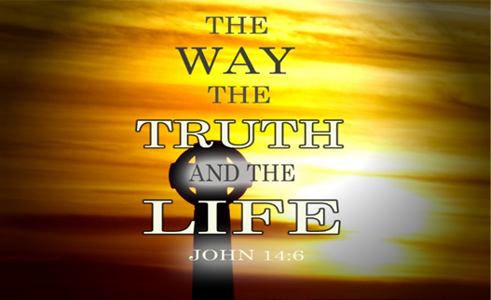

PRAYER
Lord Jesus, grant me to walk in your way, to know your truth
and to experience the life you share with your Father.
Taken from JOHN THE PEOPLE’S BIBLE COMMENTARY by Richard Burridge

Who is Christ for us today?
- I am……….

Nurturing our Faith
Bible Study Group

17th October 2022
Fleet URC & Beacon Hill URC

Who is Christ for us today?
The teaching of Jesus was always relevant and meaningful to his audience. He used metaphors and analogies that would have struck powerful chords with those who heard them, to help him reinforce a particular point. Opening prayer led by Karen
The ‘I am’ sayings continued
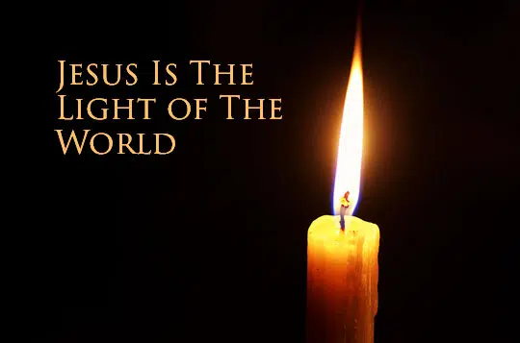
I am the Light
Scripture references: Genesis 1: 3 -5, Exodus 13:17-22, John 7-9, Revelation 21:23-25, Leviticus 23
John 1:1-5, John 8:12, 1 John 1:5-7
For discussion:
- What do you feel when you think of light? Of darkness? Do you have an immediate mood response?
- What was Jesus trying to get across to His listeners?
- What makes us shine?
For personal meditation
- In what ways are you still choosing to walk in spiritual darkness?

I am the Way, the Truth and the Life
For discussion:
- While we read John 14:1-11, jot down what stands out to you? Why is that?
- Are there any other texts that help you understand? e.g. Jesus is the way to what? Scripture: Acts 4:12
- What does the reading from John tell you about the disciples?
- How does this passage nurture the promise of hope for us?
- Is this a principle we live well or do we need God’s help to do this?
For personal reflection:
- Hebrews 4: 12 says that the Word of God is living and active. Having thought about the ‘I am’ statements, think about what active steps this study points you towards in your own Christian path.
Jesus is all we need to get to heaven. He is the way – not only does He show us the way, but he is also the doorway that leads to eternal life. As we abide in Him and walk with Him, we are walking in the ways that lead to life and a glorious future in heaven.
He is the truth. Everything He says is true. Because we can depend on Him, because he is trustworthy, we can know that the way He shows us is dependable and perfect. If we follow Him we can be certain of eternal life. In Him, life is full, delightful, abundant and prosperous.
My little book of Jesus (2005)

