PRAYER
God of faithfulness and truth,
You sent your servant John the Baptist to preach in the desert
and summon the people to repentance.
Make us and all things new,
that in the wilderness of our world and in our lives,
we also may prepare a way for Jesus. Amen

— adapted from Common Order by Rev. Chris Wigglesworth. Posted on the Church
of Scotland’s excellent Starters for Sunday website.

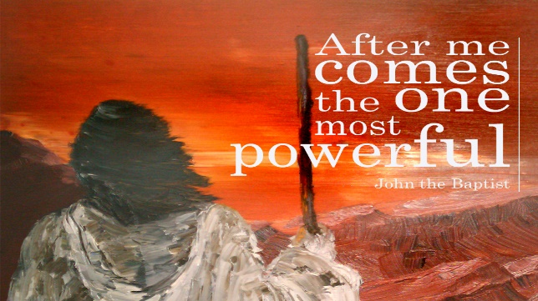

*Please send any images of John the baptist you like to Karen. We can then screen share them at the Bible Study
Materials adapted from: advent.pdf Scottish Bible Study & Changing Stables ALTERnativity.

Advent 2022
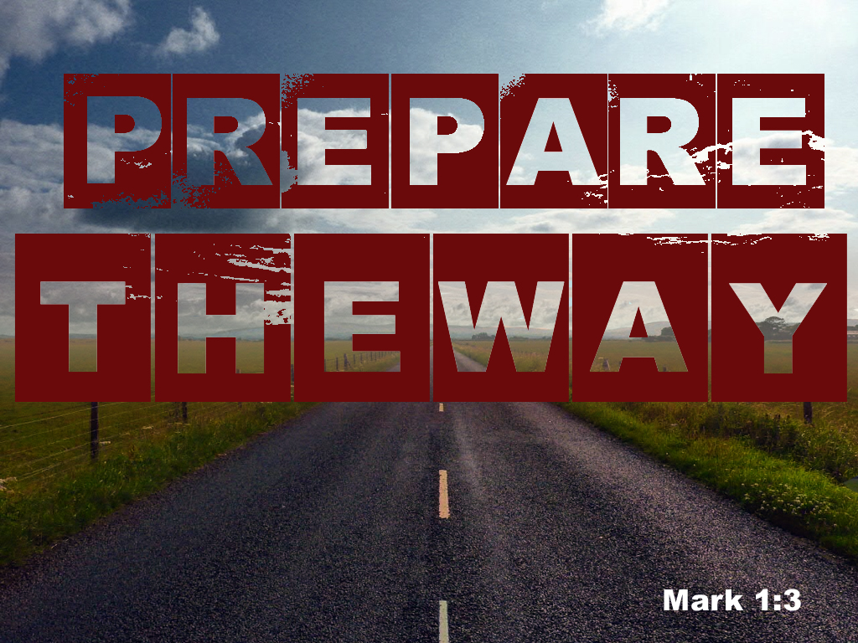
Nurturing our Faith
Bible Study Group
21st November 2022
Fleet URC & Beacon Hill URC

Advent 2022: Prepare the way
Opening prayer led by Karen
Mark 1: 1 -8
1 The beginning of the good news about Jesus the Messiah, the Son of God, 2 as it is written in Isaiah the prophet:
‘I will send my messenger ahead of you, who will prepare your way’ – 3 ‘a voice of one calling in the wilderness, “Prepare the way for the Lord, make straight paths for him.”’
4 And so John the Baptist appeared in the wilderness, preaching a baptism of repentance for the forgiveness of sins. 5 The whole Judean countryside and all the people of Jerusalem went out to him. Confessing their sins, they were baptised by him in the River Jordan. 6 John wore clothing made of camel’s hair, with a leather belt round his waist, and he ate locusts and wild honey. 7 And this was his message: ‘After me comes the one more powerful than I, the straps of whose sandals I am not worthy to stoop down and untie. 8 I baptise you with water, but he will baptise you with the Holy Spirit.’

1. While we read Mark 1: 1 - 8, jot down what stands out to you. Perhaps consider the initial tone of the text. Does it change at any point?
2. What words would you use to describe how John looked? Which prophet does this remind you of? Do you have any images of him you would particularly like to share? *
3. Why do you think the writer mentions the wilderness in particular?
4. What do you think
a) are the characteristics of John the Baptist’s ministry?
b) is the Old Testament prophecy John the Baptist fulfils?
c) the role of the prophet is in Scripture?
5. What does this particular passage tell us about Jesus?
6. How might you recognise a modern-day John the Baptist and where might you recognise a prophetic word being spoken today? What kind of things might he say today?
7. Where or how would you hear the voice of the Holy Spirit speaking today?
8. How might our reflection help us to prepare for a more meaningful celebration of Christ's coming this year?

